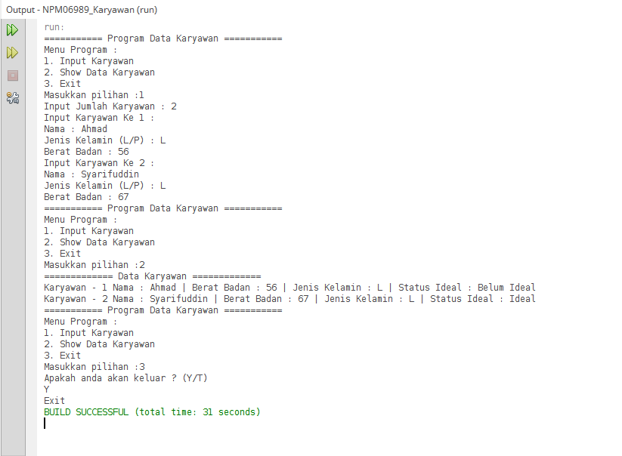

Keterangan Source Code :

--------------------------------------------------------------------------------------------------------------------------------------------------------------------------------------------------------------------------------------------------------------------------------------------------------------------------------------------------------------------------------------------------------------------------------------------------------------------------------------------------------------------------------------------------------------------------------------------------------------------------------------------------------------------------------------------------------------------------------------------------------------------------------------------------------------------------------------------------------------------------------------------------------------------------------------------------------------------------------------------------------------------------------------------------------------------------------------------------------------------------------------------------------------------------------------------------------------------------------------------------------------------------------------------------------------------------